EMPLOYEE ASSISTANCE PROGRAM
POST DOCTORAL FELLOWS (employees of UHN who have signed on for the benefits plan)
Your Employee Assistance Program (EAP) offered by Morneau Shepell is a voluntary, confidential counselling and referral service for you and your immediate family members. Family members, spouse and dependents as defined in your benefit plan - are eligible to use the EAP.

The program is designed to help you with personal or work-related pressures and stress BEFORE they lead to more serious difficulties.

EAP covers a broad range of concerns that you or your family members may be experiencing. “Covers” means that you don’t have to pay to use this service.
Office of Research Trainees-UHN
101 College Street
13th floor
Toronto M5G 1L7
Phone 416-634-8775
www.uhntrainees.ca
These concerns may include:
Family and Parenting | Gambling
Childcare and Eldercare | Career and Vocational
Marital or other Relationships | Grief
Personal and Emotional | Health
Stress (including job-related) | Financial
Anxiety and Depression | Legal  Life is hard  It’s OK to ask for help.
Alcohol and Drugs

Toll-free, 24 hours a day, 7 days a week
1st time appointments and counselling: 1 800 387-4765
General information: 1 888 814-1328
My EAP mobile application available on the App Store

Kind & Practical Help
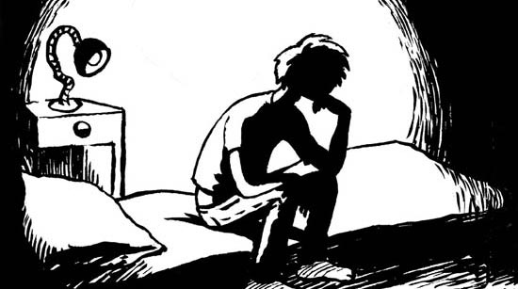

UHN & ORT Emergency & Community Resources

Date of publication

UHN Emergency
PM, TGH, TWH, KDT, TRI-UC, TRI-LC, TRI-RC | 5555
Police, Fire, Medical | 911
TRI-UC Secu | 416-597-34223070
TRI-LC Security | 416-597-3422x6226
TRI-BC Security | 416-597-3422x2503

UHN COMMUNITY
TRI Trainee Executive |  | tritraineecommittee@gmail.com
Office of Research Trainees |  | ort.admin@uhnresearch.ca
Oasis Wellness Centre cu |  | TGH -1 NU 168 near Tim Horton’s
WalkSafe! (if you want an escort when walking between your vehicle and work) |  | Call Security
Occupational Health & Safety |  | - Heather Pattenden 416-597-3422 x3775  - Deb Poeta  416-790-4683 (cell); 416-597-3422 x 3051 /2167 / 6261  - Mt Sinai emerg (UC)  - Sunnybrook emerg (RC/LC)
BC  LC  RC  UC  PM TGH TWH | Bickle Centre  Lyndhurst Centre  Rumsey Centre  University Centre  Princess Margaret  Toronto General Hospital  Toronto Western Hospital |  | @ 130 Dunn Ave.  @ 520 Sutherland Dr.  @ 345 & 347 Rumsey Rd.  @ 550 University Ave.  @ 610 University Ave.  @ 200 Elizabeth St.  @ 399 Bathurst St.

TORONTO COMMUNITY

Mental Health Distress
Anishnawbe 24/7 Mental Health Crisis Management Service (Aboriginal clients) | 416-891-8606
Drug and Alcohol Helpline (Ontario) | 1-800-565-8603
Gernstein Centre Mental Health 24hr Crisis Line | 416-929-5200
Good2Talk Post-Secondary Student Helpline | 1-866-925-5454
LGBTQ Youth Line | 1-866-268-9688
Mental Health Helpline (Ontario) | 1-866-531-2600
Ontario Problem Gambling Helpline | 1-888-230-3505

SEXUAL ASSAULT/SAFETY
Assaulted Women’s Helpline | 416-863-0511 | TTY 416-364-8762
Distress Centres | 416-408-4357
Hope 24/7 (Peel Rape Crisis Centre) | 1-800-810-0180
Sexual Assault/Domestic Violence Care Centre | 416-323-6040
Support Services for Male Survivors of Sexual Abuse | 1-866-887-0015
Toronto Rape Crisis Centre | 416-597-8808
Victim Support Line (Ontario) | 416-314-2447
Women’s Support Network of York Region | 1-800-263-6734 or 905-895-7313

