Title: Teaching CRISPR at UHN
Subtitle: A pilot course pairs learners with experts to share practical knowledge about this novel technology.
Text:
By Dr. Jason De Melo, UHN Postdoctoral Fellow
UHN is a world leader in patient care and health research. In this capacity, UHN participates in the teaching and training of many scientists, technicians, clinicians and nurses who have a dramatic impact on patient care and biomedical research—nationally and internationally. Teaching occurs daily in the hospitals and research institutes, generally in the form of supervisor and mentorship roles from experienced clinicians and scientists, and in cooperation with closely affiliated academic institutions; yet, more formal teaching opportunities are eluding many of our trainees. This has become apparent for our research fellows who require such experiences when applying for new academic positions once their training here at UHN has been completed. This gap provides a potential opportunity for research trainees looking for more formal teaching experiences.
As a leading research hospital, one advantage UHN has over many other institutions is its ability to quickly incorporate and develop expertise in new and emerging technologies. To this end, no technology has become more topical, disruptive and relevant in the past five years than the genome editing technique CRISPR/Cas. CRISPR/Cas was identified as an adaptive immune mechanism in bacteria to ward off infection by viruses. It utilizes a RNA programmable nuclease (Cas) to cut foreign DNA. This system has been re-purposed for genome engineering. The programmable nature of Cas proteins allows them to be targeted to any piece of DNA in any genome and in contrast to previous genome editing technologies, CRISPR/Cas is much faster and much cheaper. Its applications have already been extended to medical research, agriculture, synthetic biology and therapeutics. UHN and the Greater Toronto Area have many leading research labs utilizing CRISPR/Cas to screen for therapeutic vulnerabilities, produce research models and developtherapeutics for genetic diseases.
The timely and revolutionary nature of CRISPR/Cas thus makes it the ideal topic for a pilot course in research techniques. This course—entitled Genome Editing Techniques and Applications—was developed over the past nine months by myself (Dr. Jason De Melo) and my supervisor Dr. Linda Penn, in collaboration with UHN Research, the Michener Institute for Education at UHN and the ORT (Dr. Penn is the Director of the ORT). Eight instructors participated: myself; two post-doctoral fellows from UHN (Drs. Fraser Soares and Zahraa Mohamed-Ali); and five graduate students from UHN (Corey Lourenco, Diana Resetca, Joseph Longo, and Ayesh Seneviratne) and SickKids (Daria Wojtal). The premise of the course was to provide learners with a foundation in the theories behind CRISPR/Cas and provide a simulated research experience in which they would utilize molecular cloning techniques to clone a CRISPR/Cas9 targeting plasmid and edit the genome of a simple bacteria. The format of the course focused on providing practical experience in genome editing techniques for the learners. To accomplish this, the course was designed as a two-week, full-day program comprising theory-focused lectures, active-learning protocol design sessions and a hands-on wet-lab. What differentiated this program from many others was the active learning protocol design, which was tied directly to the hands-on wet-lab. Experimental protocols were not provided for the learners; instead, these were developed by the learners on the morning of the lab session and carried forth in the afternoon. The course culminated in a group project in which the learners designed a genome editing project from the ground up, utilizing the theory and techniques they learned throughout the course to propose an experiment in a grant proposal format.
We launched the registration for this course in late March and we were met with incredible interest despite little to no advertising. We capped our enrollment at 20 students which comprised undergraduate and graduate students, as well as technicians from nearby institutions. The course ran for two weeks in late August and was a tremendous success—both for the students and for the instructors. Many of the students in the course commented on how relevant the material was and on the benefit of an in depth and personal learning experience from very skilled and knowledgeable researchers. In particular, the learners appreciated designing the protocols themselves as this provided a strong and grounded understanding of the experiments that they were completing. All students stated their interest in taking additional courses from experts at UHN.
As for the teaching experience, the instructors had the opportunity to lecture and supervise the lab component of the course. This opportunity not only provided the instructors with teaching experience, but also tangible feedback from students that can be included in their CVs and Teaching Dossiers for future academic applications.
In all, we have proof-of-concept for a teaching model here at UHN that can not only benefit the learners seeking to develop expertise, but also provide the teaching experiences needed by our research trainees for their future careers. As an institution, we are uniquely able to provide this personal teaching experience in highly relevant and technical topics and it was clear from learner feedback that we should continue to provide offerings such as this pilot course. Clearly, they would not only be welcomed by learners, but would also enrich the research environment here in Toronto.

Image:
Image Caption: Courtesy of Conference Services UHN

Additional Images:

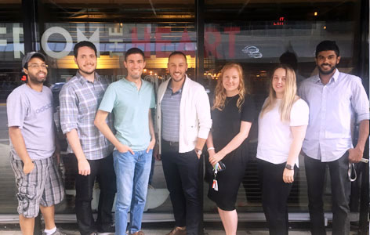
Image Caption: T.As and Professor of the GETA Course. From (L-R) Dr. Fraser Soares, Corey Lourenco Joseph Longo, Dr. Jason De Melo (Instructor for GETA course), Daria Wojta, Diana Resetca and Ayesh Seneviratne. Missing: Dr. Zahraa Mohamed-Ali.

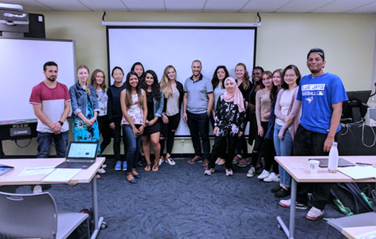
Image Caption: 2017 GETA Course Students with their Instructor.

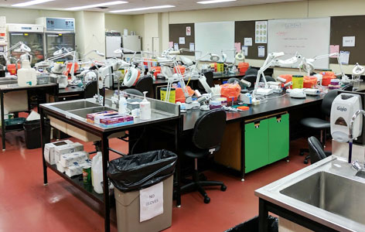
Image Caption: The lab space at the Michener Institute was used to conduct all required experiments for the GETA course.

Title: MBP Summer Student Program Success

Subtitle: MBP Summer Student Poster Day provides platform for students to have scientific discussions.

Text: The Department of Medical Biophysics Summer Student Poster Day took place on August 21. Twenty undergraduate students had the opportunity to give a poster presentation summarizing the research they conducted over the summer. Students were able to exercise their presentation skills and engage in scientific discussions with peers and colleagues.

For a second year, the winner received the Dr. Arthur Axelrad Summer Student Excellence Award. Dr. Axelrad, Senior Scientist at UHN, was one of the founding members of the Ontario Cancer Institute, now the Princess Margaret Cancer Centre. He was a member of several departments at the University of Toronto, including the Department of Medical Biophysics, and was recognized for his contributions with the prestigious title of University Professor. Dr. Axelrad had a particular interest in cultivating the minds of young scientists, and would invite science fair winners to work in his lab during the summer. The goal was to give these students an opportunity to have a first-hand experience of the world of research.
Andrew Lam, summer student in Dr. Scott Bratman’s lab, was this year’s recipient of the Dr. Arthur Axelrad Excellence Award for his research achievements in the area of cancer.
The ORT would like to congratulate all of the winners of the MBP Summer Student Poster Day: Andrew Lam, Barry Fung and Kevin Liu.

The ORT would also like to extend a thank you to the Axelrad family for attending this year’s poster day as well as their ongoing support to help cultivate the future minds of research!

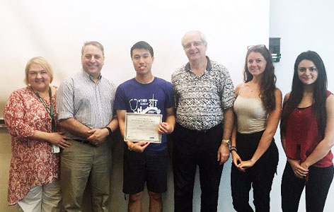
Image Caption: Dr. Arthur Axelrad’s daughter-in-law, sons and granddaughters pictured with the recipient of the award. (L-R) Brigitte Talevski, David Axelrad, Andrew Lam, Rob Axelrad, Stephanie Axelrad and Heather Axelrad.

Additional Image:

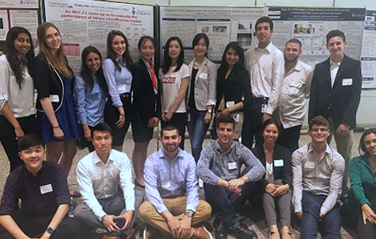
Image Caption: The participants at the 2017 Medical Biophysics Summer Student Poster Day.

Title: What does the p-value tell you?
Subtitle: Recent guidelines and best practices show the importance of applying the appropriate statistical tests to interpret data.

By Krithika Muthukumaran, ORT Times Writer and UHN Trainee
Scientists are in the midst of a reproducibility crisis. One of the factors leading to poor reproducibility is the application of weak statistical tests, including the misuse of the p-value, a common test used to judge if the results are important and the hypothesis is true. Prompted by a growing concern among statisticians on how conclusions are being drawn from research data, this crisis led to the American Statistical Association to release—for the first time since its founding 177 years ago—a set of principles and guidelines on how to appropriately apply the p-value.
The p-value is used to test if the null hypothesis that postulates absence of an effect or difference between two groups is true. It measures how compatible the data is with the null hypothesis, and a lower p-value suggests that your data has evidence to reject the null hypothesis. A p-value equal to or less than 0.05 is generally accepted by the scientific community as being statistically significant. The recent guidelines developed by the Association suggest that this need not be always true: They advise not to make scientific conclusions or policy decisions based solely on p-values. They caution that this is important to prevent muddled thinking, in which p-values are given greater importance than the larger question. There must be full transparency and the data analysis along with the statistical tests used, calculations and data must be reported along with the research finding. The limitations of p-value should be understood and more sophisticated tools, such as Bayesian tests, must be used when feasible.
Proper training and continuously updating your knowledge to improve statistical literacy will greatly help prevent misinterpretations. Nature Methods publishes a monthly column called points of significance (https://www.nature.com/collections/qghhqm/pointsofsignificance) to aid biologists with basic statistical concepts, statistical methods and experimental design.
Good statistics is part of good science. It means that there is a well thought out experimental design, critical evaluation of possible sampling errors, logical understanding and interpretation of data, and complete reporting. Be aware of both the applications and limitations of statistical tests, adopt the appropriate statistical methods and have more stringent thresholds before claiming success. This would reduce the chances of false positive results and help make sound conclusions.

Image Caption:
Courtesy of http://dastornews.com/2016/09/networking-moving-beyond-the-usual-suspects/#prettyPhoto

Title: ORT Travel Award

Subtitle: The ORT would like to congratulate the recipients of the July 2017 ORT Travel Award competition.
Text:
The ORT is committed to providing support for research trainees at UHN. The ORT provides a limited number of travel awards to support graduate students and postdoctoral fellows to attend national and international conferences to disseminate their research. The ORT is pleased to announce the awardees of the July 2017 ORT Travel Award!

Graduate Students (alphabetical order):
- Alexandre Guet-McCreight Supervisor: Dr. Frances Skinner, Krembil
- Ali Hussain Supervisor: Dr. Laura Ailles, PM
- Hardeep Singh Supervisor: Dr. Kristin Musselman, TRI
- Jonathon Chio Supervisor: Dr. Michael Fehlings, Krembil
- Katharine Dunlop Supervisor: Dr. Jonathan Downar, Krembil
- Krystal Menezes Supervisor: Dr. Lorraine Kalia, Krembil
- Samir H. Barghout Supervisor: Dr. Aaron D. Schimmer, PM
- Teresa Tsui Supervisor: Dr. Murray Krahn, TGRI
- Tijana Simic Supervisor: Dr. Elizabeth Rochon, TRI
- Timothy Samuel Supervisor: Dr. Ralph DaCosta, PM
- Wanida Nuwisait Supervisor: Dr. Peter Carlen, Krembil

Postdoctoral Fellows (alphabetical order):
- Dr. Andrea Bandini Supervisor: Dr. Yana Yunusova, TRI
- Dr. Arvind Singh Mer, Supervisor: Dr. Benjamin Haibe-Kains, PM
- Dr. Fanxing Zeng Supervisor: Dr. Nigil Haroon, Krembil
- Dr. Musaddeque Ahmed Supervisor: Dr. Housheng Hansen He, PM
- Dr. Pallavi Jain Supervisor: Dr. Marianne Kortizinsky, PM
- Dr. Panayiota Philippou Supervisor: Dr. Eleftherios Diamandis, PM
- Dr. Samah El Ghamrasni Supervisor: Dr. Trevor Pugh, PM
- Dr. Sergi Clotet Freixas Supervisor: Dr. Ana Konvalinka, TGHRI

Image Caption:
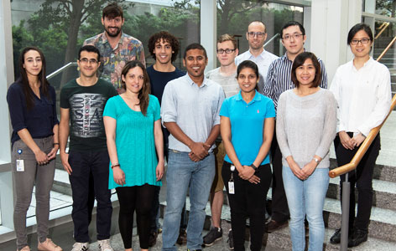
Image Caption: July 2016 ORT Travel Award winners. (L-R, top) Dr. Sergi Clotet Freixas, Timothy Samuel, Alexandre Guet-McCreight, Dr. Andrea Bandini, Jonathon Chio, Teresa Tsui.
(L-R, bottom) Dr. Samah El Ghamrasni, Samir H. Barghout, Dr. Panayiota Philippou, Dr. Musaddeque Ahmed, Dr. Pallavi Jain, Wanida Nuwisait.

Conference Reports:
Title: Posture and Gait Research
Subtitle: Combining Mobility Research and Smart Technology to Reduce Age-Related Incidents.
Text:
Conference: International Society of Posture & Gait Research, June 25-29, 2017, Fort Lauderdale, Florida, USA
Conference Highlight: Balance control is fundamental to human behaviour. Sensory, motor and cognitive components are studied through basic or applied science from neurophysiology to biomechanics of functional mobility.
Conference Article:
Two related symposia were of particular interest: implementing mobility research into policy and practice; and using smart technology to prevent age-related decline in balance, strength, physical activity and behavioural complexity. Both initiatives were discussed from international perspectives and highlighted the importance of underlying theory, models and/or frameworks.
In North America and Australia, the Knowledge-to-Action cycle is used to identify barriers to/facilitators of implementation as well as guide development of interventions for reactive balance and fall prevention. Feasible assessment tools and synthesized evidence-based guidelines were recommended for successful clinical translation of research findings. Individual psychosocial drivers of uptake/adherence and organizational challenges such as lack of funding/awareness or changing priorities are important factors to consider when designing strategies.
The delivery of health care services via mobile communication devices, mHealth, has recently expanded with improved technology. A focus on behaviour change is increasingly recognized as a crucial component in the efficacy of this approach. The European Project “PreventIT” has developed an electronic version of the adapted Lifestyle-intergrated Functional Exericse programme (eLiFE) that incorporates social cognitive and habit formation theory. Goal-setting, personalized advice, motivational messages and real-time feedback are features of this intervention, which includes strength and balance/agility tasks to increase physical activity in young-older adults. Advanced sensors in smartphones/watches have created the potential to continuously monitor, in a relatively cheap and unobtrusive way, health status information. Self-assessment and virtual coaching functions may empower people to improve their lifestyle and reduce risks.

Image:

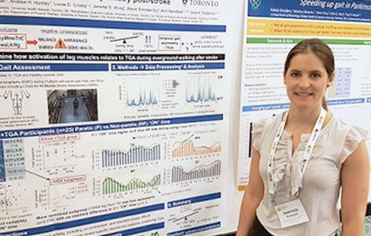

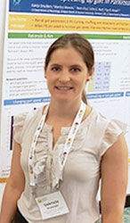
Image Caption: Conference Attendee, Gabriela Rozanski, Postdoctoral Fellow. Supervisors: Dr. Avril Mansfield and Dr. Kara Patterson, TRI.

Title: Advances in Spinal Injury Research
Subtitle: The 2017 conference discusses the latest in spinal injury research, care and rehabilitation.
Conference: American Spinal Injury Association 2017 Annual Scientific Meeting, April 26-29, 2017,
Albuquerque, NM, USA
Conference Highlight: The 2017 American Spinal Injury Association (ASIA) conference provided a vast spectrum of topics in spinal cord injury that spans the continuum of novel research, care, and rehabilitation.
Conference Article:
The American Spinal Injury Association 2017 Annual Scientific Meeting provided an excellent field for making connections with the world’s leading experts in the field of spinal cord injury. The conference began with pre-conference courses on Pediatric Spinal Cord Injury and Urology. One highlight of this event was a keynote lecture on diaphragm pacing in children with spinal cord injury. This is a process in which electrical stimulation is applied to the diaphragm to simulate breathing. This method has been shown to be more effective than traditional breathing apparatus, as it allows patients to breath on their own and eliminates complications that are associated with the breathing apparatus. Similarly, functional and therapeutic electrical stimulation has also shown promising results on improving functional recovery of movement in the lower limb in children as well as aiding in urological applications in adults.
Furthermore, interesting work on a computerized clinical measure was presented. This assessment tool consists of an algorithm that adjusts the questions based on the previous answers, thus eliminating any questions that are not relevant to the patient’s level of injury. The conference also explored social topics such as accessibility issues during vacation and controversial topics including physician-assisted dying. Beyond traditional scientific lectures, the conference also provided an opportunity for young investors to present their work though poster sessions and short presentations. A session on award-nominated abstracts included work on a wearable computer vision system for upper extremity assessment, from the Adaptive Neurorehabilitation Systems Lab at the Toronto Rehabilitation Institute – University Health Network. The location of the conference, Albuquerque, NM, provided an opportunity for attendees to learn about the rich cultural heritage of the indigenous peoples of the Americas, as well as the history of New Mexico.

Image:
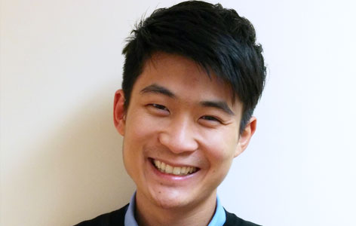

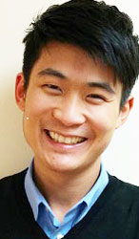
Image Caption: Conference Attendee, Jirapat Likitlersuang, PhD Candidate. Supervisor: Dr. Jose Zariffa, TRI.

Title: National Neurotrauma Symposium 2017
Subtitle: The 2017 NNS brings together investigators from around the world.
Text:
Conference: National Neurotrauma Symposium 2017, July 7-12, Alta, Utah, USA
Conference Highlight: Through the integration of clinical, translation and basic science, the annual National Neurotrauma Symposium (NNS) encouraged transdisciplinary discussion of central nervous system injury.
Conference Article:
The annual NNS meeting attracts some of the most prominent and influential leaders in the field of neurotrauma. The year’s conference featured sessions on injury-induced autoimmunity, mitochondrial dysfunction, stem cell-mediated repair of the spinal cord and evolving concepts on secondary injury.
Especially interesting was a panel discussion titled, “Acute Spinal Cord Injury (SCI) and the Therapeutic Window: Are We Chasing Realistic Targets?”, with Drs. Michelle Hook (Texas A&M University), William Whetstone (University of California), J. Marc Simard (University of Maryland) and Linda Noble-Haeusslein (University of Texas at Austin). During this session, the panel engaged the audience through critical debate on the feasibility as well as the clinical efficacy of early interventions. Relatedly, this discussion was followed by a clinical trial update pertaining to four ongoing studies for spinal cord trauma, including the promising Vertex Pharmaceuticals’ phase 2b/3 SPRING trial and the phase 2/3 RISCIS study. Focusing on cell therapy, Asterias Biotherapeutics showed the baseline demographics of SCI patients transplanted with oligodendrocyte progenitor cells and Dr. Kim Anderson-Erisman (University of Miami) shared the progress of the autologous Schwann cell transplantation clinical trial.
On another note, Dr. Wassarman (University of Wisconsin) gave a compelling presentation on a novel model of traumatic brain injury in Drosophila, which allows for large scale genetic screens in relation to injury pathology. There were also four excellent anniversary lectures by Drs. Wise Young (Rutgers University), John Povlishock (Virginia Commonwealth University), Edward Hall (University of Kentucky) and Alan Faden (University of Maryland).
Most importantly, the mid-day poster sessions allowed for stimulating discussion, invaluable feedback and plentiful networking opportunities.

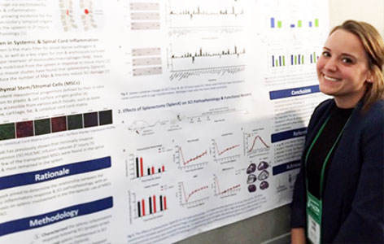

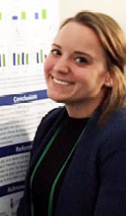
Image Caption: Conference Attendee, Anna Badner, PhD Candidate. Supervisor: Dr. Michael Fehlings, Krembil.

Title: Biomaterials & Tissue Engineering
Subtitle: Discussing ground breaking research in Biomaterials and tissue engineering.

Text:
Conference: Gordon Research Conferences: Biomaterials & Tissue Engineering, Holderness, NH, USA Conference Highlight:
The conference brought together group of highly talented researchers in Biomaterials. The intimate setting fostered informal discussions around the cutting edge work in the field.
Conference Article:
Gordon research conferences (GRC) are a unique family of symposiums that serve as a forum for international researchers to come together and discuss cutting edge research in biological, chemical, and physical sciences and technologies that relate. The 2017 GRC on Biomaterials and Tissue Engineering was designed to pull together leading clinicians, scientists and engineers in discussion of the use of material-related strategies in solutions for disease remediation and tissue repair. The 2017 conference theme was "Building Novel Molecular Designs and Basic Biological Discoveries into Successful Medical Technologies"

In this the area of biomaterials, researchers are consistently working to couple the cutting edge of healthcare with the chemistry behind material technologies. At this conference, there was an emphasis on this notion, and presenters focused on displaying unpublished data of cutting edge technologies. Overall, it seems there was an emphasis on the use of materials to modulate and interact with the human biological system. In the past, there was a notion that biomaterial design should focus on ensuring materials were inert upon implantation. Forward movement of designing materials to be instructive and responsive to the cell microenvironment has begun to expand the possibilities with both synthetic and naturally derived materials. As an example, a few talks at this meeting discussed materials with linkages that contain a peptide sequence that can be degraded by a particular enzyme. This can allow for release of a drug carrier payload in a specific microenvironment where an enzyme is present for controlled release. This focus of research will significantly expand the opportunities for materials in medicine in the future.
Image:

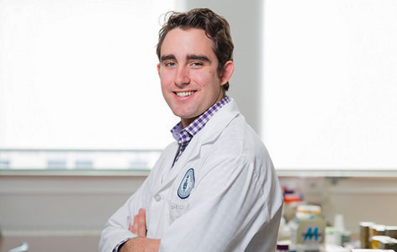

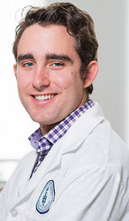
Image Caption: Conference Attendee, Locke Davenport Huyer, PhD Candidate. Supervisor: Dr. Milica Radisic, TGRI.

Monthly Event Timeline

Title: Current Trends in Pharmaceutical Commercialization
Event Text: UHN's Office of Technology Development and Commercialization and University of Toronto's Rotman School of Management presents a session to discuss current trends in Pharmaceutical commercialization, including entry/exit, profitability, employment and R&D spending, alliances, and acquisitions. This session will be conducted by Professor Will Mitchell, Professor of Strategic Management at Rotman,
Event Date: October 24th, 2017 from 4-6 p.m.
For info: https://www.eventbrite.ca/e/current-trends-in-pharmaceutical-commercialization-tickets-37489553263

Title: From the Bench to Business: The BenchSci Story
Event Title: Are you a graduate student/post doc looking for industry career opportunities? Have you ever wondered what it takes to run a successful start-up then this session is for you! Come learn about BenchSci, a local start-up company created by PhD students, some of whom trained right here at UHN!
Date:: October 10, 2016
For info: https://www.eventbrite.ca/o/uhns-office-of-research-trainees-ort-7490129441

Title: Science Writer Positon
Event Title: ORT is recruiting a highly motivated part-time Science Writer to write and edit content for our monthly newsletter – The ORT Times. The successful candidate will be either a graduate student or postdoctoral fellow conducting research at one of the UHN Research Institutes. The Science Writer will be expected to help generate ideas for content and write one editorial, tutorial or summary of a research paper, per month.
Deadline: September 29, 2017
For info: ort.admin@uhnresearch.ca

